My Mindful Study

Abroad Experience

|  |
| --- |
|  |

**Name**

Studied Abroad with **Program**

From **College/University**

Dedication to Future Self:

Table of Contents

First Impressions 1

My Study Abroad Support Network 2

Obstacles (to) Overcome 3

Leveraging My Experience 4

Was it Really Culture Shock? 5

My Post-Study Abroad Support Network 6

Author in Images 7  
Author’s Study Abroad Epilogue 8

Note from Garble Founder 9

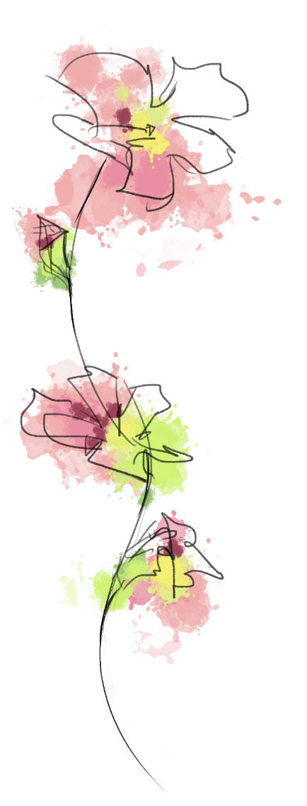First Impressions  
*Ted Talk Inspiration:* [*Where are you a Local?*](https://www.ted.com/talks/taiye_selasi_don_t_ask_where_i_m_from_ask_where_i_m_a_local)  
[*Go international*](https://www.youtube.com/watch?v=8BcaB4PiecU)[*Why Study Abroad*](https://www.youtube.com/watch?v=P1Zha2CrJZ0)

My main reason for studying abroad is…

I’ll become a local abroad by…

To help me understand what is going on around me I…

Things that make me go “Hmm??”

*Go deeper:*

*What was your decision-making process and what do you want to get out of this experience? What are you going to do to make sure you get what you want out of the experience while you are abroad?*

**Study Abroad Support Network**

|  |  |  |
| --- | --- | --- |
| **While abroad**  **Who in MY life is most likely to:** | **Name(s)**  **Method(s) of Contact** | **I can too!** |
| **Wipe my tears** |  |  |
| **Listen to me vent** |  |  |
| **Tell me the truth** |  |  |
| **Give me advice** |  |  |
| **Spend time with me** |  |  |
| **Encourage me to get out of a funk** |  |  |
| **Notice I am sad** |  |  |
| **Help me solve a problem** |  |  |
| **Remind me things will get better** |  |  |
| **Not laugh when I cry ugly** |  |  |
| **Notice I need help** |  |  |
| **Cheer me up** |  |  |
| **Take deep breaths with me** |  |  |
| **Go on a walk with me** |  |  |
| **Stay with me until you feel better** |  |  |
| **Answer my text messages** |  |  |
| **Check in on me** |  |  |

[*Inspired by Mental Fills Counseling Tools*](https://www.teacherspayteachers.com/Product/Ask-For-Help-A-Social-Support-System-Directory-3877408)*, Retrieved*

Obstacles (to) Overcome  
I am studying abroad in order to…

Challenges I’ve Faced So Far Include:

Obstacles I need to overcome to have my desired experience include:

What does CULTURE have to do with it??

***Go deeper:***

***I want to share this part of the story with:***

**Leveraging My Experience: How Studying Abroad Fits in My Bigger Picture**

My life in general

My studies

My career

My purpose

*If I were to consider myself as an organization, with a mission, vision, goals and targets, how would I define success? How has exposure to life and culture abroad widened my perspective and presented more options for how I can live my life? How can I leverage my personal experience from the moment I get home?*

Was it Really Culture Shock?  
  
In your experience thus far, recall and describe an instance where there was misunderstanding due to a diverging or unknown cultural perspectives.   
  
Be explicit! Why was this instance/exchange ‘cultural.’ If the issue is resolved, how was it resolved? If this issue if unresolved, how would you consider resolving it? *Best piece of advice prior to arrival:  
  
  
Best piece of advice I can offer prior to departure:*

**Post-Study Abroad Support Network**

|  |  |
| --- | --- |
|  | **Name(s)** |
| **International Students on Home Campus** |  |
| **Study Abroad Office Support Staff** |  |
| **Off-campus Affinity Groups** |  |
| **Mentor** |  |
| **Family** |  |
| **Friends** |  |
| **Fellow Study Abroad Returnees** |  |
| **…** |  |
| **…** |  |
| **…** |  |

# Author in Images

*Insert Your Chosen Images*

First Day Abroad

Month 1

Month 2

Month 3

Month 4

Last Day of This Study Abroad Journey

Favorite Image So Far

Author’s Study Abroad Epilogue: *The Flight Home*

I know I’ve changed while abroad. For example:

Before studying abroad, I never thought I could…

What I hope I take home from this experience:

I want to share my story with:

[](http://www.garble.dk)A note from Garble founder, Heather Krog:

*Studying abroad in Denmark in 2002 changed my life. I trust and believe studying abroad has a specific purpose for your journey. Remaining present in the moment, you will absorb experiences that will serve you for a lifetime. May you learn, grow, be inspired and inspire others.*