My Mindful Study

Abroad Experience
  - Name
  - Studied Abroad with Program
  - From College/University

Dedication to Future Self:

Table of Contents
First Impressions 1
My Study Abroad Support Network 2
Obstacles (to) Overcome 3
Leveraging My Experience 4
Was it Really Culture Shock? 5
My Post-Study Abroad Support Network 6
Author in Images 7
Author’s Study Abroad Epilogue 8
Note from Garble Founder 9

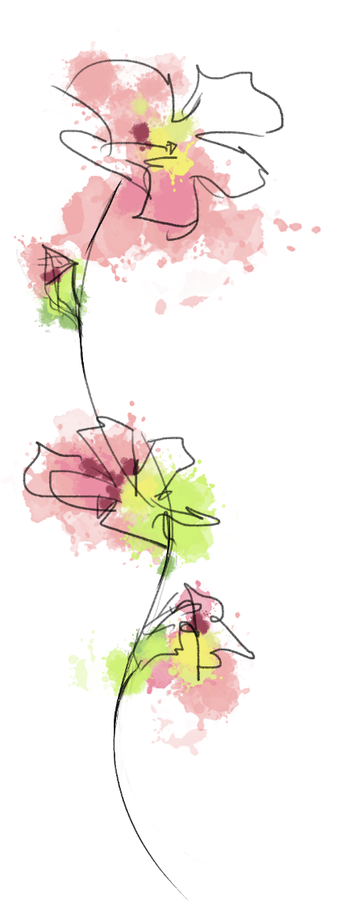
First Impressions
Ted Talk Inspiration: Where are you a Local?
Go international
Why Study Abroad
My main reason for studying abroad is…

I’ll become a local abroad by…

To help me understand what is going on around me I…

Things that make me go “Hmm??”

Go deeper:
What was your decision-making process and what do you want to get out of this experience? What are you going to do to make sure you get what you want out of the experience while you are abroad?

Study Abroad Support Network
While abroad  Who in MY life is most likely to: | Name(s)  Method(s) of Contact | I can too!
Wipe my tears
Listen to me vent
Tell me the truth
Give me advice
Spend time with me
Encourage me to get out of a funk
Notice I am sad
Help me solve a problem
Remind me things will get better
Not laugh when I cry ugly
Notice I need help
Cheer me up
Take deep breaths with me
Go on a walk with me
Stay with me until you feel better
Answer my text messages
Check in on me
Inspired by Mental Fills Counseling Tools, Retrieved
Obstacles (to) Overcome
I am studying abroad in order to…
Challenges I’ve Faced So Far Include:

Obstacles I need to overcome to have my desired experience include:

What does CULTURE have to do with it??

Go deeper:
I want to share this part of the story with:
Leveraging My Experience: How Studying Abroad Fits in My Bigger Picture
My life in general
My studies
My career
My purpose

If I were to consider myself as an organization, with a mission, vision, goals and targets, how would I define success? How has exposure to life and culture abroad widened my perspective and presented more options for how I can live my life? How can I leverage my personal experience from the moment I get home?
Was it Really Culture Shock?
In your experience thus far, recall and describe an instance where there was misunderstanding due to a diverging or unknown cultural perspectives.
Be explicit! Why was this instance/exchange ‘cultural.’ If the issue is resolved, how was it resolved? If this issue if unresolved, how would you consider resolving it?
Best piece of advice prior to arrival:
Best piece of advice I can offer prior to departure:

Post-Study Abroad Support Network
Name(s)
International Students on Home Campus
Study Abroad Office Support Staff
Off-campus Affinity Groups
Mentor
Family
Friends
Fellow Study Abroad Returnees
…
…
…

Author in Images
Insert Your Chosen Images
First Day Abroad
Month 1
Month 2
Month 3
Month 4
Last Day of This Study Abroad Journey
Favorite Image So Far


Author’s Study Abroad Epilogue: The Flight Home

I know I’ve changed while abroad. For example:

Before studying abroad, I never thought I could…

What I hope I take home from this experience:

I want to share my story with:

A note from Garble founder, Heather Krog:
Studying abroad in Denmark in 2002 changed my life. I trust and believe studying abroad has a specific purpose for your journey. Remaining present in the moment, you will absorb experiences that will serve you for a lifetime. May you learn, grow, be inspired and inspire others.

Microsoft Word Images on cover and pages 1, 3-5 and 8

