My Mindful Life

Abroad Experience
  - Name
  - Journeyed to Hometown/Country
  - To New Locality

Dedication to My Future Self:

Table of Contents
First Impressions 1
My Life Abroad Support Network 2
Obstacles (to) Overcome 3
Leveraging My Experience 4
Was it Really Culture Shock? 5
My 2-Minute Story 6
Author in Images 7
Author’s Work Abroad Epilogue 8
Note from Garble Founder 9

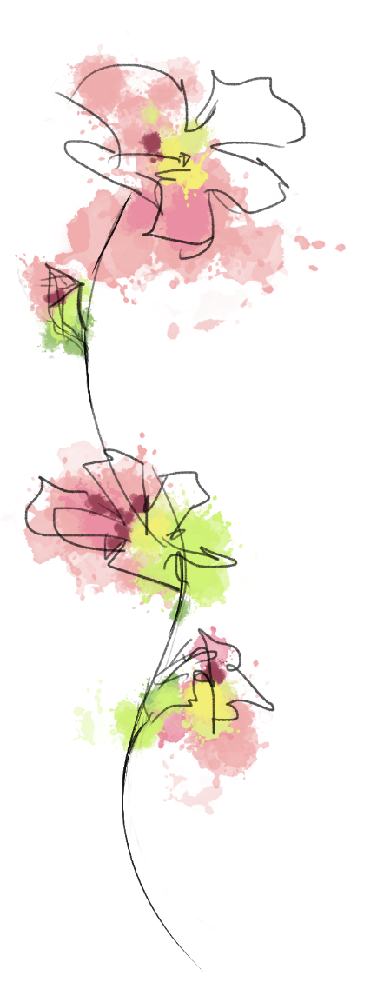
First Impressions
Ted Talk Inspiration: Where are you a Local?
My main reason for living abroad is…

I’ll become a local abroad by…

To help me understand what is going on around me I…

Things that make me go “Hmm??”

Go deeper:
What was your decision-making process and what do you want to get out of this experience? What are you going to do to make sure you get what you want out of the experience while you are abroad?

Life Abroad Support Network
While abroad  Who in MY life is most likely to: | Name(s)  Method(s) of Contact | I can too!
Wipe my tears
Listen to me vent
Tell me the truth
Give me advice
Spend time with me
Encourage me to get out of a funk
Notice I am sad
Help me solve a problem
Remind me things will get better
Not laugh when I cry ugly
Notice I need help
Cheer me up
Take deep breaths with me
Go on a walk with me
Stay with me until you feel better
Answer my text messages
Check in on me
Inspired by Mental Fills Counseling Tools, Retrieved
Obstacles (to) Overcome
I am working abroad in order to…
Challenges I’ve Faced So Far Include:

Obstacles I need to overcome to have my desired experience include:

What does CULTURE have to do with it??

Go deeper:
I want to share this part of the story with:
Leveraging My Experience: How Life Abroad Fits in My Bigger Picture
My life in general
My studies
My career
My creativity
My purpose

If I were to consider myself as an organization, with a mission, vision, goals and targets, how would I define success? How has exposure to life and culture abroad widened my perspective and presented more options for how I can live my life? How can I leverage my personal experience from the moment I get home?
Was it Really Culture Shock?
How aware are you of your own home culture? Did you become more aware of it while abroad?
In your experience so far, recall and describe an instance where there was misunderstanding due to a diverging or unknown cultural perspectives.
Be explicit! Why was this instance/exchange ‘cultural.’ If the issue is resolved, how was it resolved? If this issue if unresolved, how would you consider resolving it?
Best piece of advice prior to arrival:
Best piece of advice I can offer prior to departure:

My 2-minute Story
I live abroad…
The greatest challenge I’ve overcome thus far…
What I will take into my next career and life move…
What I learned that I could not learn at home…
Grateful to locals for…

Go deeper:
I want to share this part of the story with:

Author in Images
Insert Your Chosen Images
First Day Abroad
Month 1
Month 2
Month 3
Month 4
Last Day of This Life Abroad Journey
Favorite Image So Far


Author’s Life Abroad Epilogue: The Flight Home

I know I’ve changed while abroad. For example:

Before living abroad, I never thought I could…

What I hope I take home from this experience:

I want to share my story with:

A note from Garble founder, Heather Krog:
Studying abroad in Denmark in 2002 changed my life. In 2004 I graduated from Georgetown University in the US and relocated to Copenhagen for my first post-graduate job. I trust and believe that living abroad has a specific purpose for your journey. Remaining present in the moment, you will absorb experiences that will serve you for a lifetime. May you learn, grow, be inspired and inspire others.

